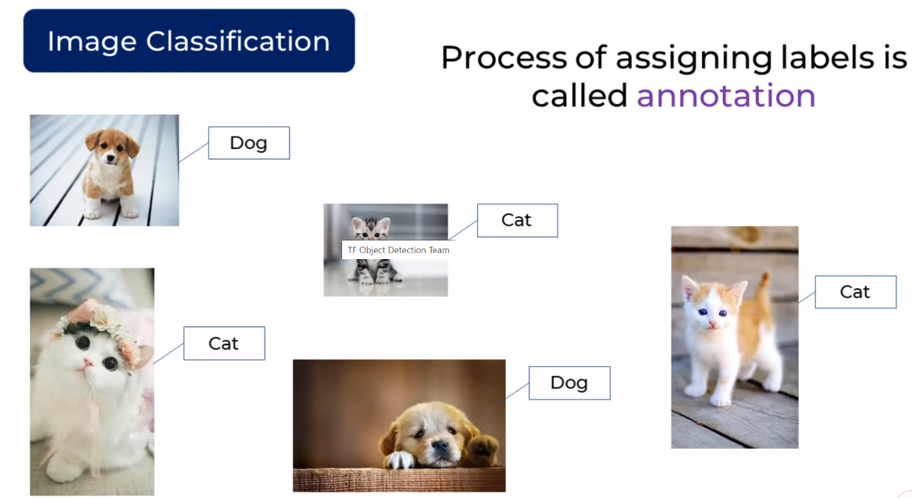

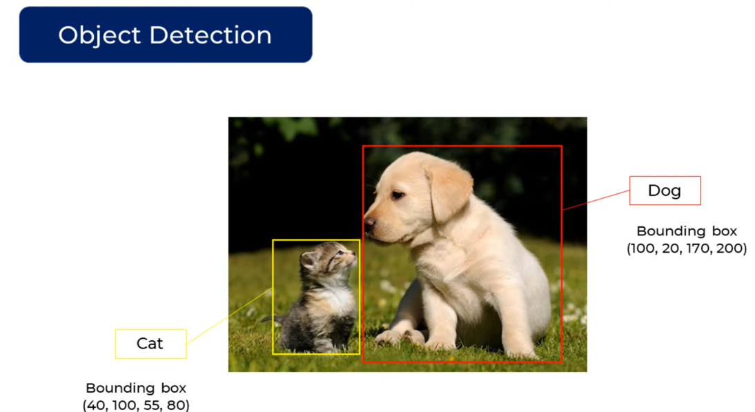

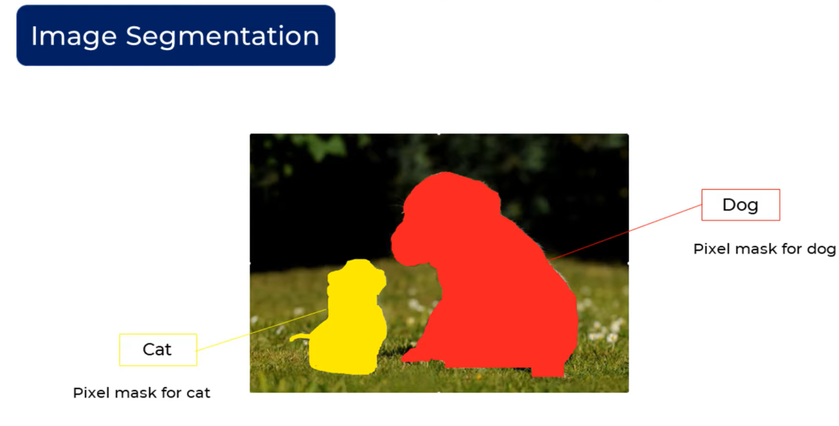

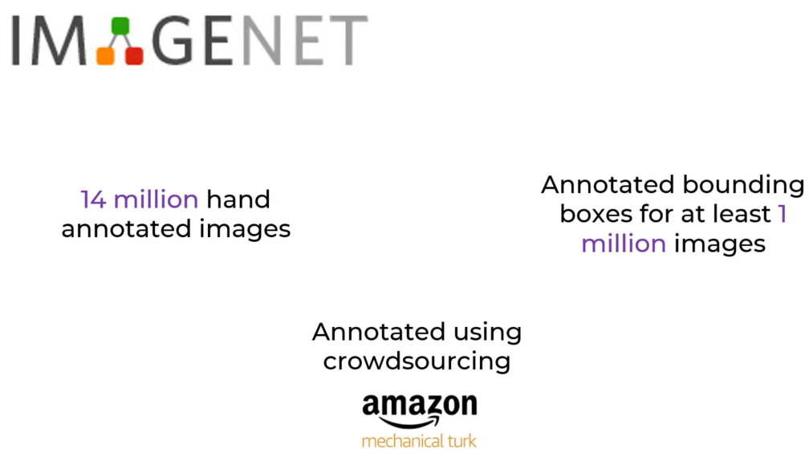

**Sliding Window Object Detection Technique -**

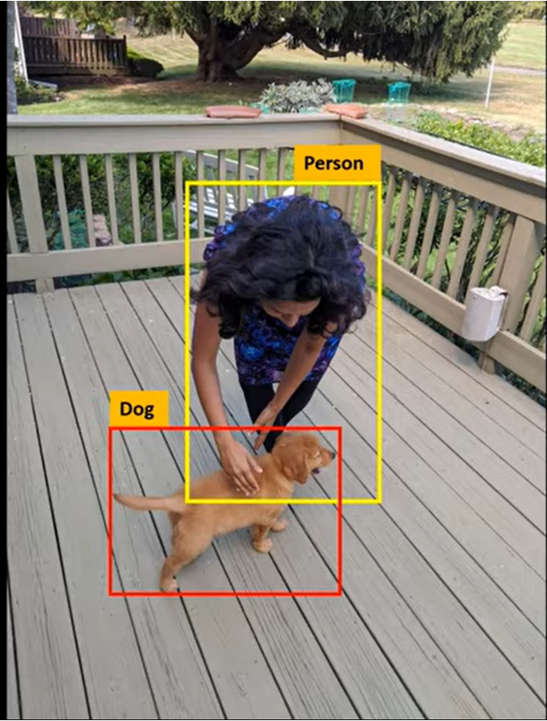

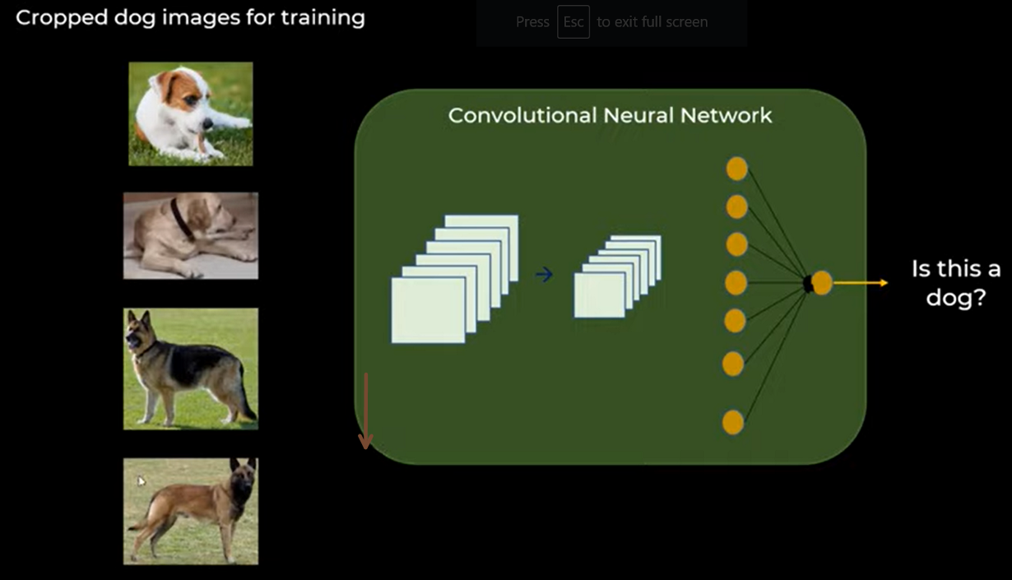

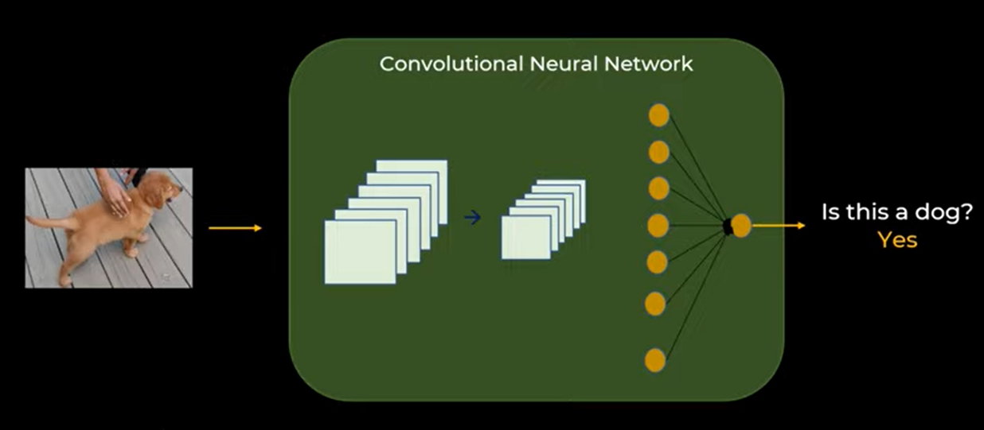

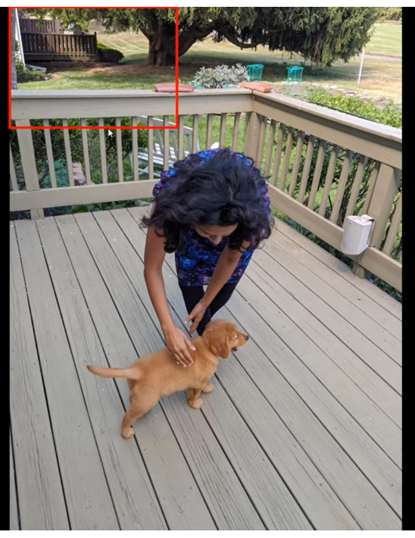

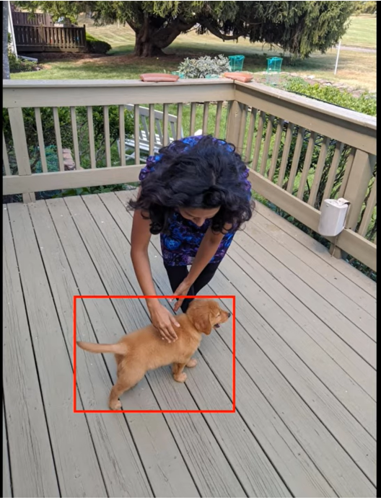

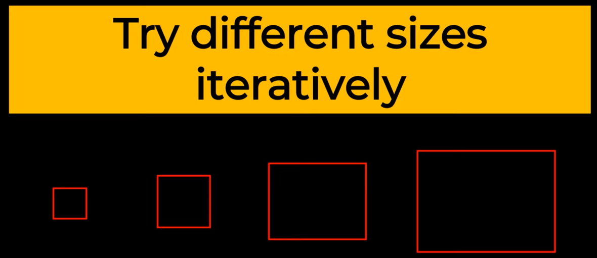

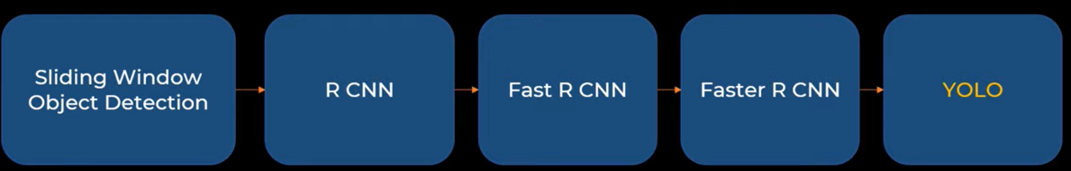

**YOLO -**

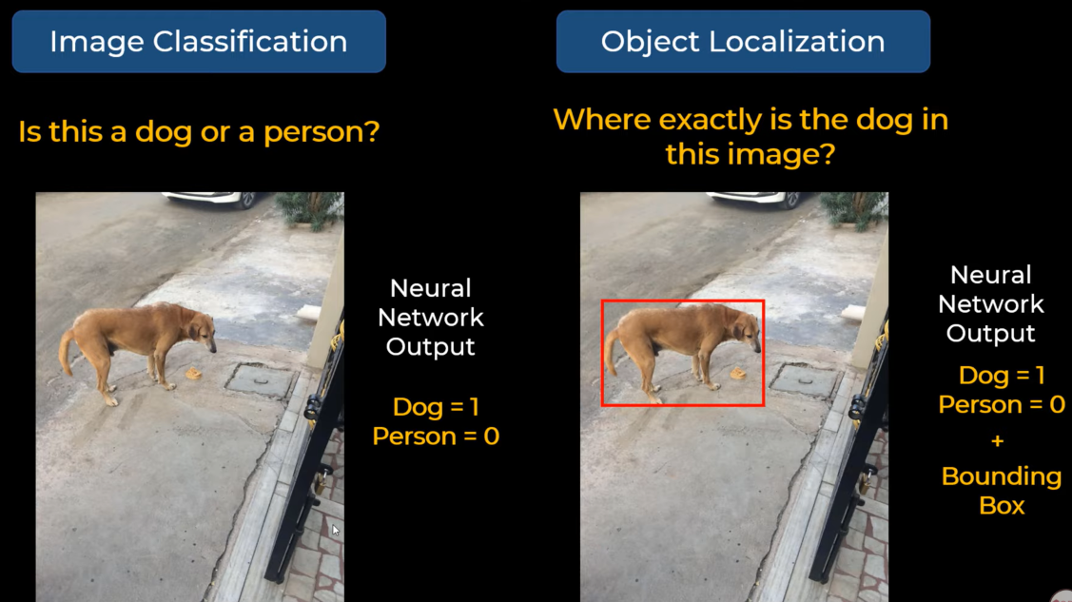

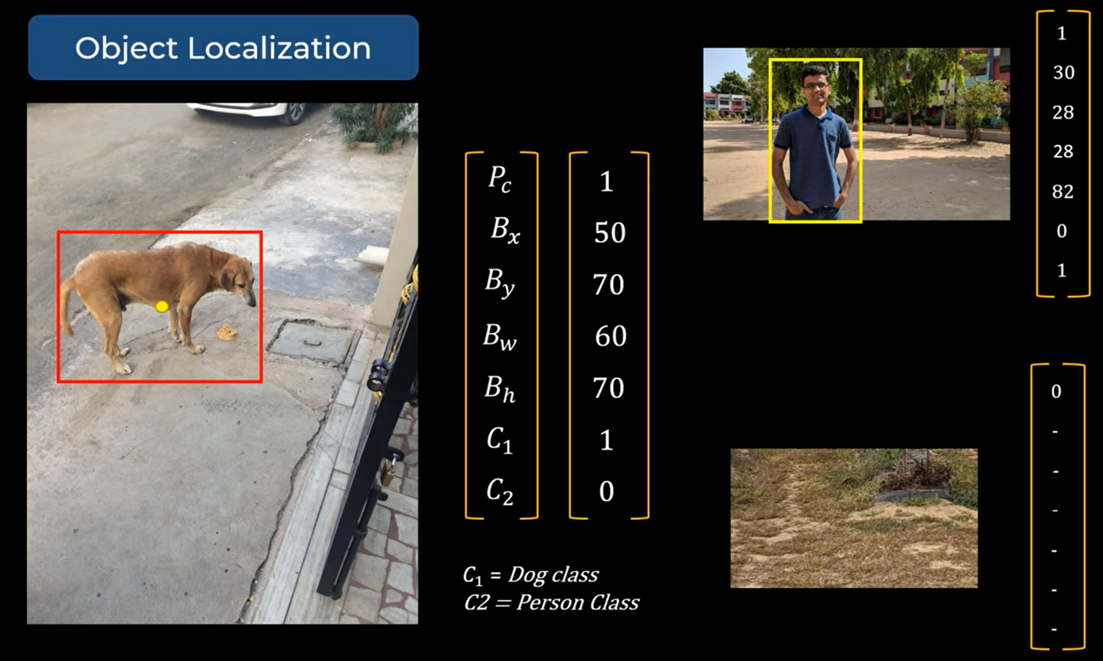

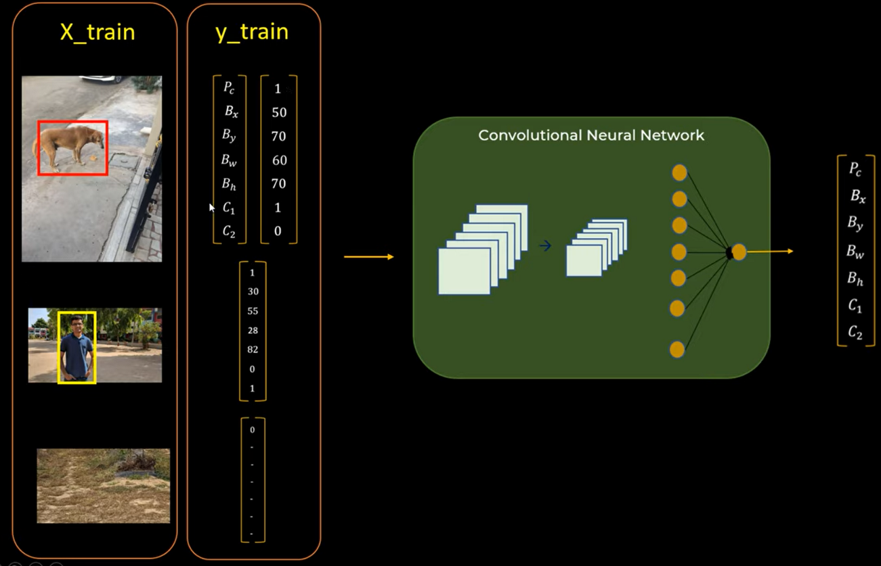

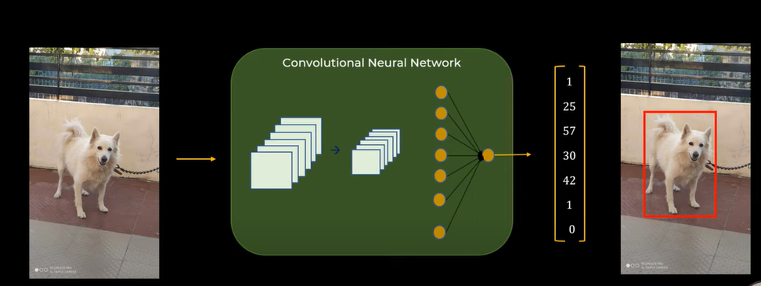

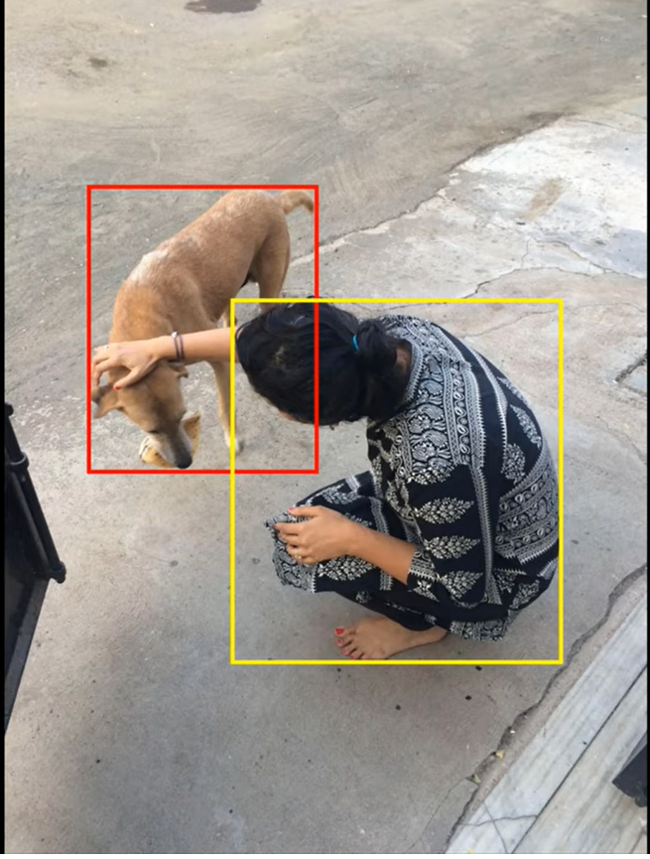

**Multiple Objects in one Image -**

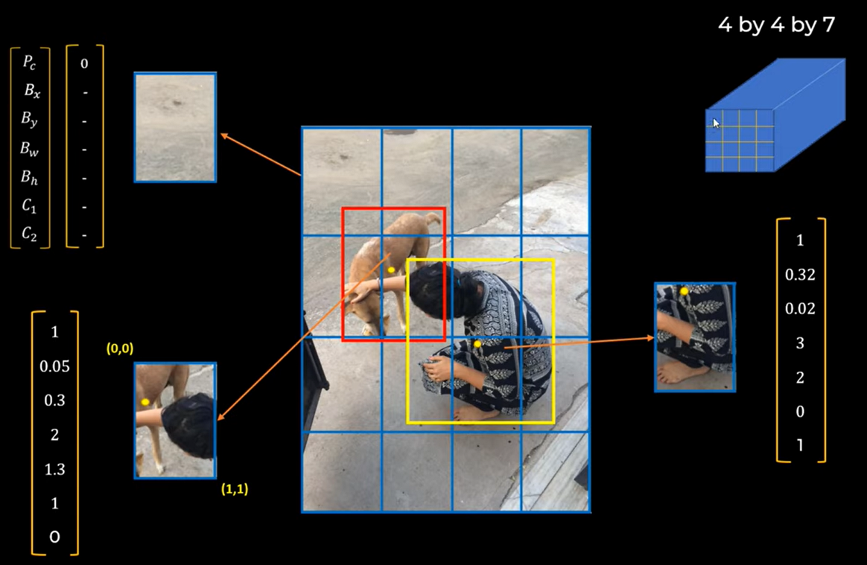

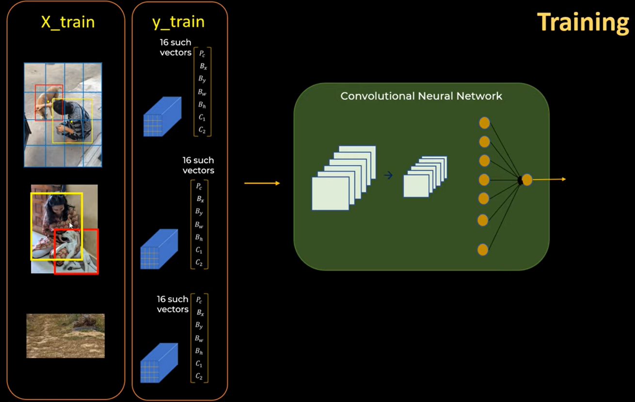

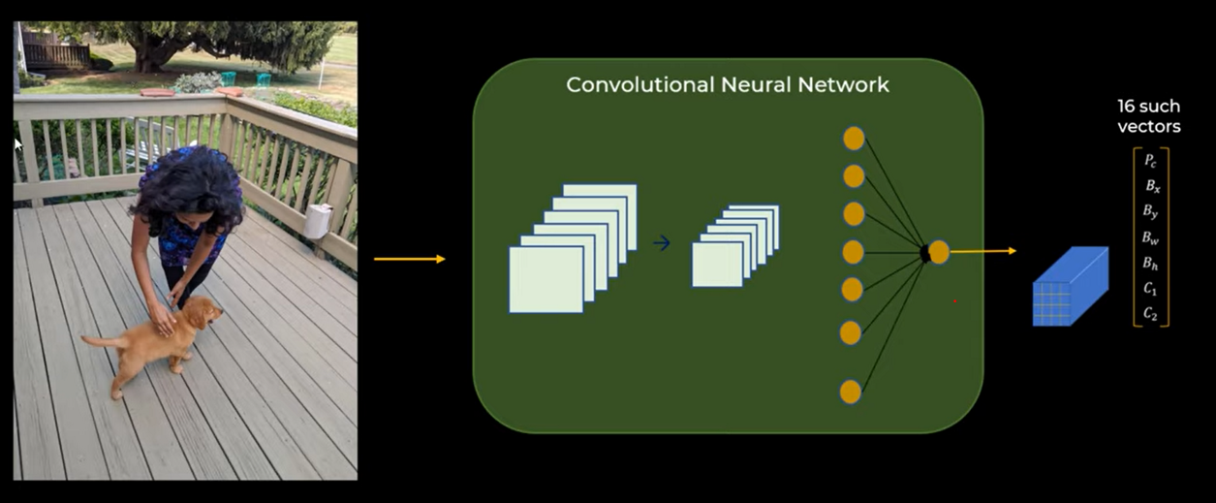

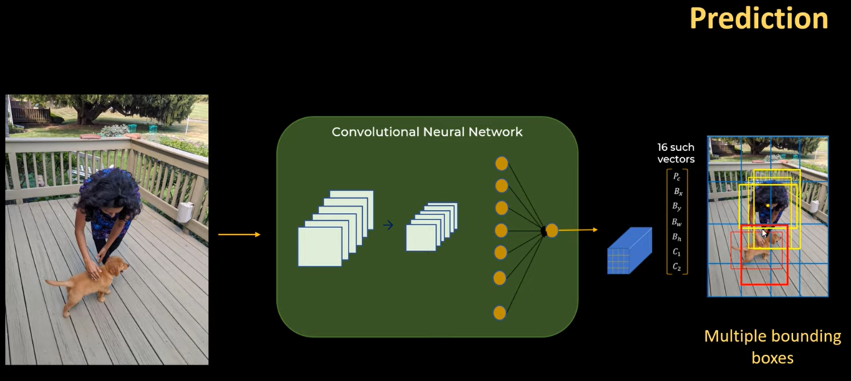

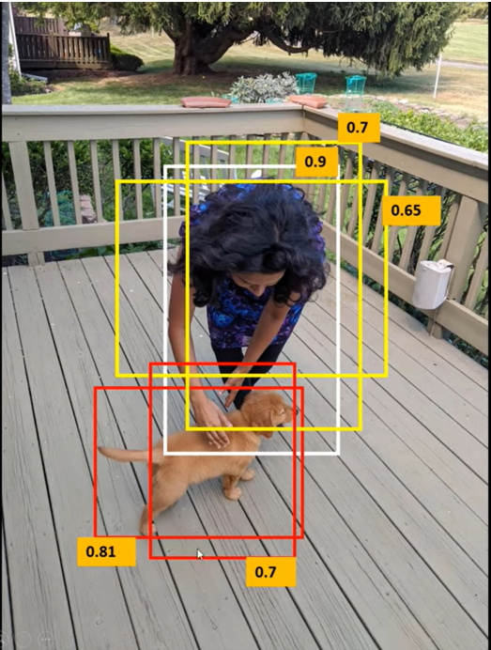

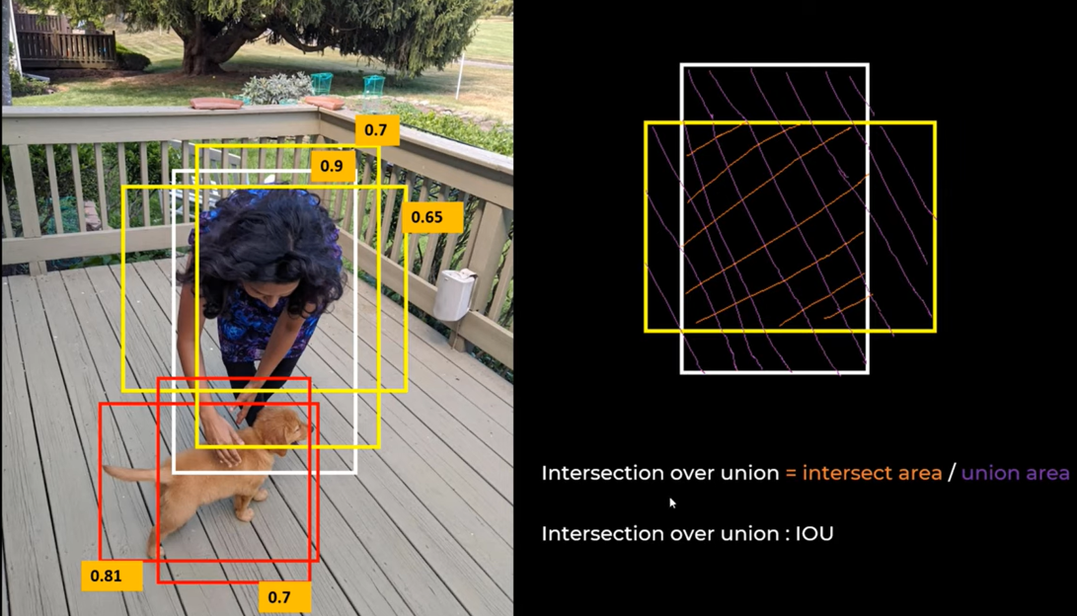

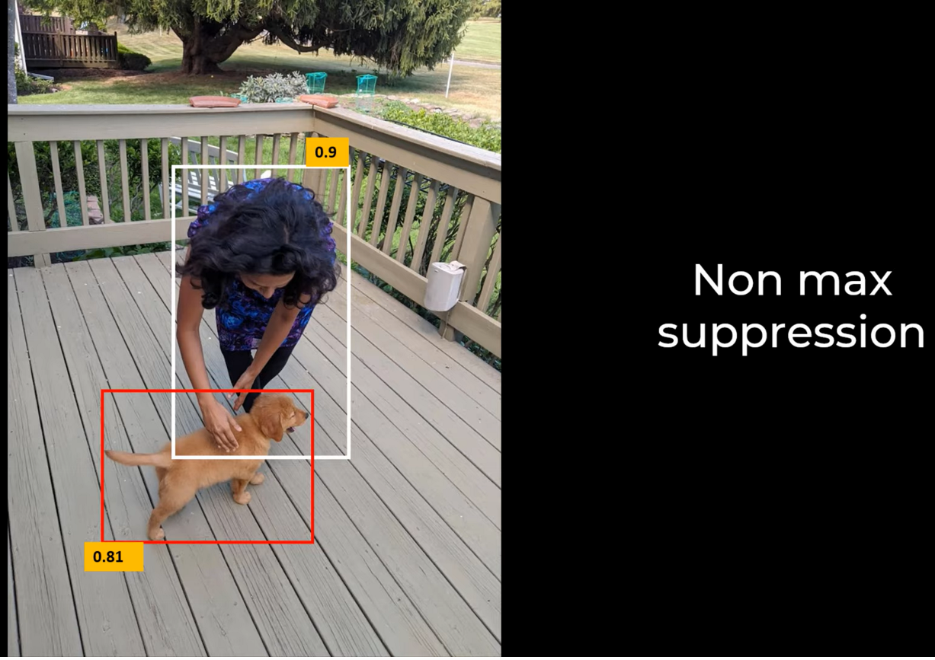

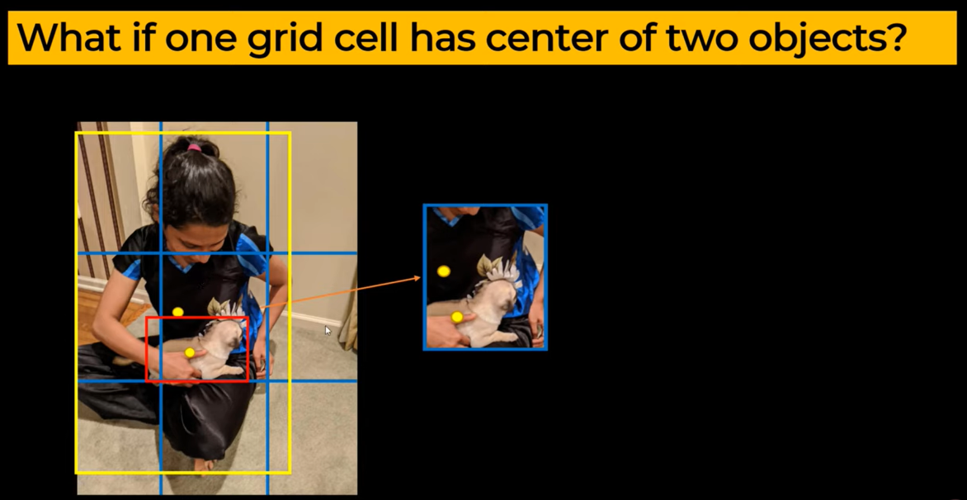

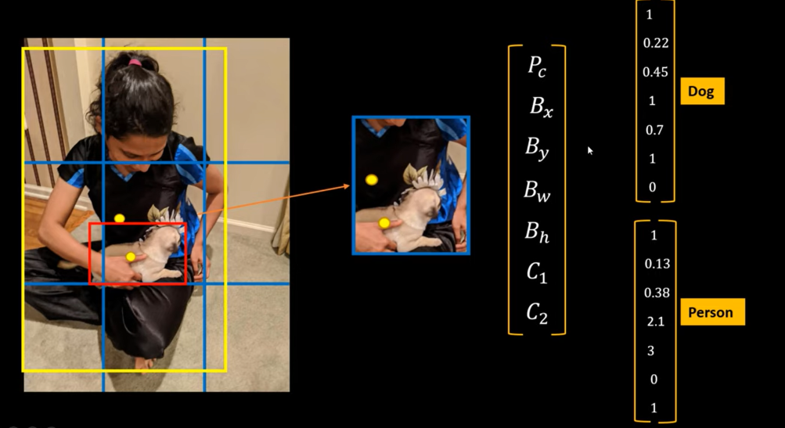

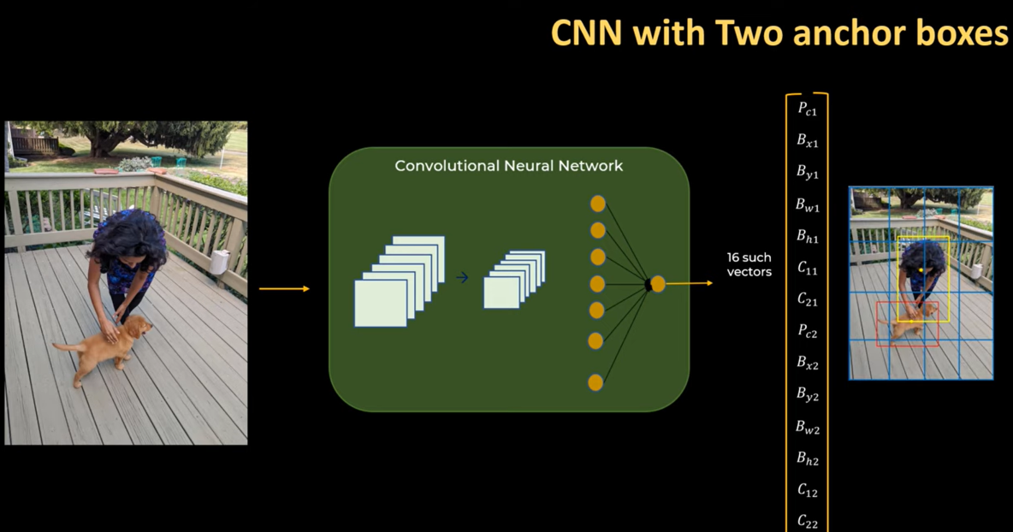

<https://jonathan-hui.medium.com/ssd-object-detection-single-shot-multibox-detector-for-real-time-processing-9bd8deac0e06>

<https://www.mihaileric.com/posts/object-detection-with-rcnn/>

<https://mlwhiz.com/blog/2019/12/05/od/?utm_campaign=demystifying-object-detection-and-instance-segmentation-for-data-scientists&utm_medium=social_link&utm_source=missinglettr>

**Inception Architecture**

<https://towardsdatascience.com/a-simple-guide-to-the-versions-of-the-inception-network-7fc52b863202>

<https://towardsdatascience.com/an-intuitive-guide-to-deep-network-architectures-65fdc477db41>

**Faster RCNN code -**

<https://github.com/AarohiSingla/Faster-R-CNN-on-Custom-Dataset>

**Data Prep -**

<https://github.com/AarohiSingla/Faster-R-CNN/blob/main/data_prep.ipynb>

**RPN Layer -**

<https://github.com/AarohiSingla/Faster-R-CNN/blob/main/rpn_layer.ipynb>

**Classifier -**

<https://github.com/AarohiSingla/Faster-R-CNN/blob/main/classifier.ipynb>